Duval County Chapter

Farm to School Event
On September 13, our local farm partner, Native Fresh, visited students at John E. Ford K-8 School to share about their aquaponics greenhouse in downtown Jacksonville and the importance of supporting sustainable farming practices. The students had great questions, and even took home some radish and lettuce seeds to start their own garden!

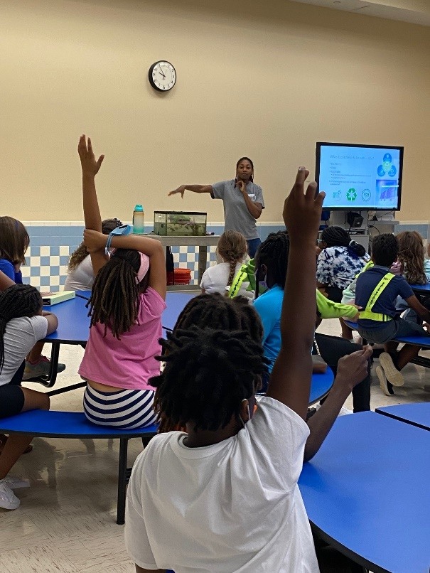
Student Choice Voting Week
Giving high school students a voice in deciding what food concepts are featured and potential new menu items, Student Choice brings the latest food trends to school menus and empowers our older students to provide feedback to improve our offerings.

During the week of September 26-30, we featured two new concepts on our high school menus for students to choose and vote on. The concept that wins the popular vote will be featured on high school menus this winter. Here’s what students voted on:

Flame – Fresh take on grilled burgers and sandwiches with flavors that elevate your meal
- Hot Honey Breakfast Burger
- French Onion Grilled Chicken Sandwich

Bok Choy – Asian flavors inspired by celebrity chef, Jet Tila
- Pineapple Chicken with Brown Rice
- Vietnamese Turkey Meatball Sub with Fresh Vegetables

Special Menu Days
On September 22, we celebrated the fall equinox with some autumn-inspired recipes like our home-style chicken pot pie and our harvest spinach salad.

To honor Johnny Appleseed, the American Legend known for introducing apple trees throughout the northern United States, we offered students an apple chicken salad with cinnamon apple muffin on September 26 to celebrate his contributions.

