Entry Form: You must use this form—other forms will not be accepted and your entry will be disqualified. Upload this form along with your award entry to the FSNA Dropbox: https://www.dropbox.com/request/9j8speH4RWl4mybXl7NR. Please fill out carefully and completely. The information on this form will be used to create the FSNA awards presentation and winner certificates.

Nominee: ___Lawrence Spears____________________________________________

Job Title: ___FNS Manager____________________________________

Employer: ___Orange County Public Schools_________________________________

Address: __6000 North Lane ___________________________

City: __Orlando_______________ State: Fl___ Zip Code: _32808_________________

County: __Orange______________________ FSNA Region Number: _4____________

********************************************************************

Name of Person Nominating: ____Tony Jenkins__________________________________
(Please Print)

Job Title of Nominator: _____Senior Manager Training and Quality Assurance__________

Work Address of Nominator: ____8101 Benrus Street____________________________

City: _____Orlando___________________________ State: _Fl___ Zip Code: _32827______

Home or Cell Phone #: __407-927-6196_____ Work Phone #: _407-858-3110__________

Email: ____Tony.Jenkins@ocps.net_______________________________________

By completing this form and submitting the award, you are attesting that the above information as well as the award entry information and documentation are accurate and true to the best of your knowledge.

Explain the reason(s) why you have nominated this individual for this award. There is not a minimum or maximum word count. A maximum of 15 pictures will be accepted (clipart is not considered a picture). Pictures should be inserted directly into the document.

I nominate Lawrence Spears, Orange County Public Schools, Food Service Manager at Meadowbrook Middle School, for the Community Humanitarian Award. Lawrence has been very active in many community service initiatives each year! One big event Lawrence serves at each year is the annual Holiday Food Giveaway event. Orange County Public Schools along with the local Second Harvest Food bank teams up each year to provide food for needy families over the course of Winter break, when students are not in school. Lawrence has played a major role in the event’s planning and execution. He has been the site leader for the event, and has even hosted the event at his school. As the site leader, Lawrence had the responsibility of organizing over 100 volunteers and logistically plan the afternoon. At the conclusion of each Holiday Food Giveaway event, Lawrence and his teams would have serviced more than 500 families!

Another volunteer effort Lawrence participates in is feeding of the homeless charity event. Lawrence also helps provide gifts for the children in those homeless families. The highlight of the event is a special holiday meal where Lawrence cooks the food and sets up the event. Many homeless families have benefited from this event. The time, talent, and resources provided by Lawrence helps make the event a success!

One last community service initiative I want to highlight Lawrence on is his involvement with the Meadowbrook Middle School’s basketball team. Lawrence has sponsored several players who would not otherwise have the means in providing basketball shoes and other player needs. Meadowbrook Middle School resides in a low income area of Orange County; it’s a Community Eligibility Provision school where all students eat breakfast, lunch, and after school supper at no charge. The financial support provided by Lawrence eliminates this burden that would otherwise fall on the player’s parents. Aside for the financial support, Lawrence also serves as a mentor and role model for these same players.

For these reasons and many others, I believe Lawrence Spears is very deserving of this Community Humanitarian award! His compassion and service to others extends far beyond his home and workplace.
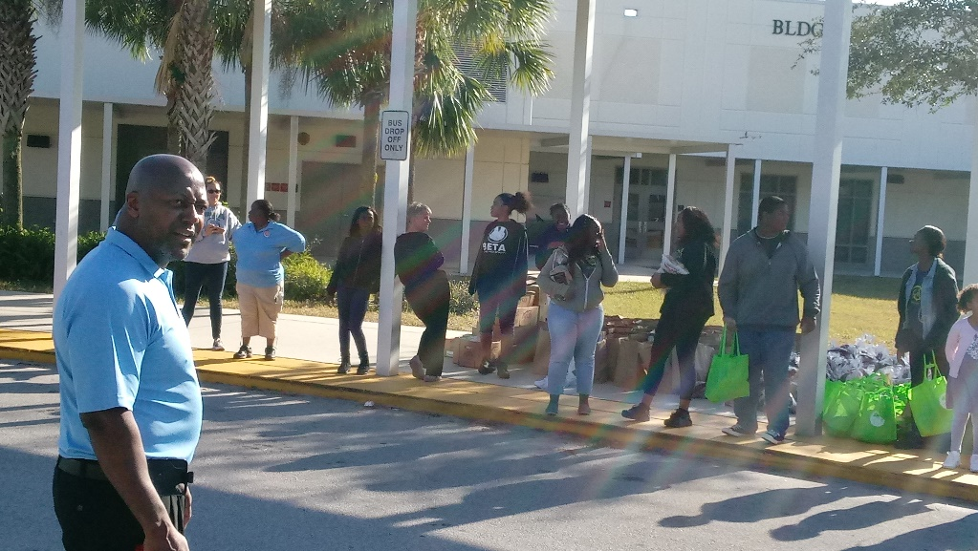
Lawrence preparing the volunteers for the annual Holiday Food Giveaway event.
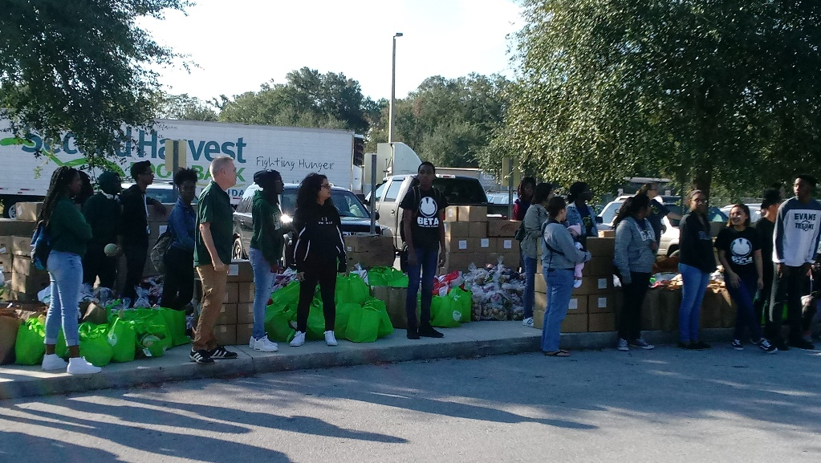
Volunteers are ready for cars to start lining up to receive their bags of food.
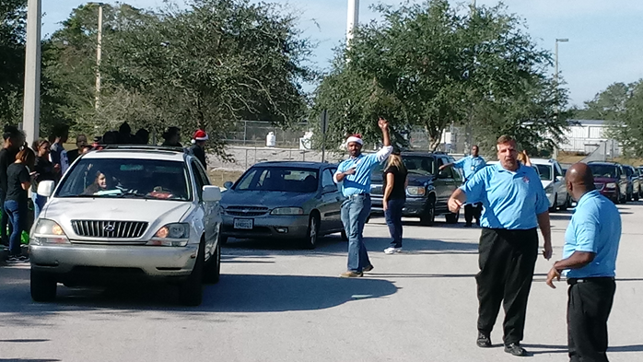

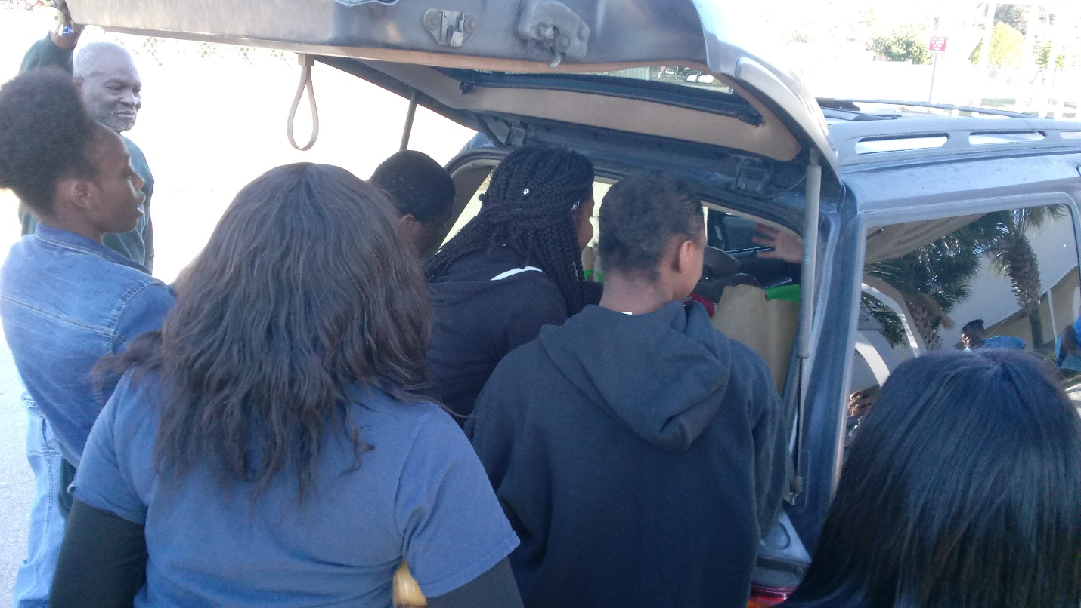
Volunteers loading up a vehicle with bags of food. More than 500 families received food at this event!
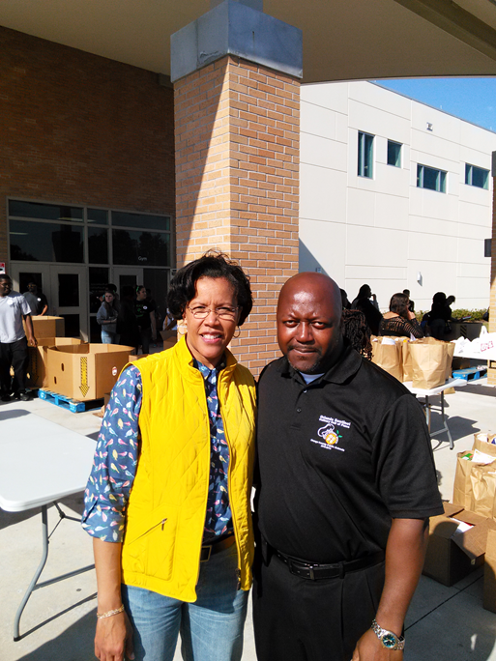
Lawrence with Orange County Superintendent Dr. Barbara Jenkins at one of the Food Giveaway events.
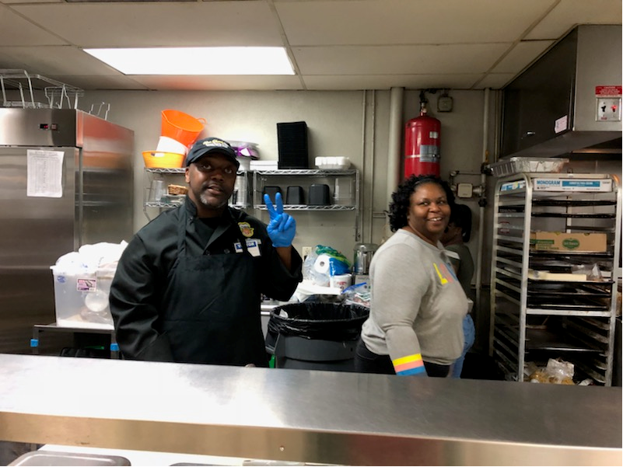
Lawrence getting set up to prepare food for the homeless at an annual charity event.

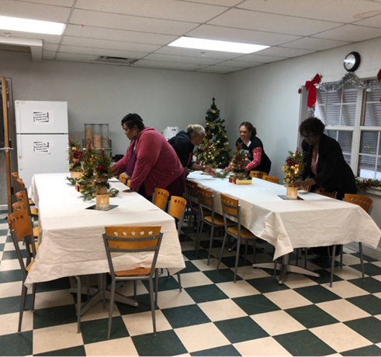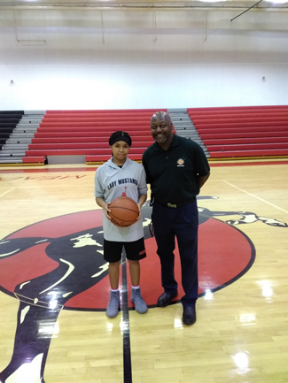
Tables get set for the homeless to enjoy a hot meal. One of the student basketball players - sponsored by Lawrence.

